

## Human Eye

**Human Eye and the Colourful World**

* The human eye is an important and valuable sense organ which uses light and enables us to see the colourful world around us.

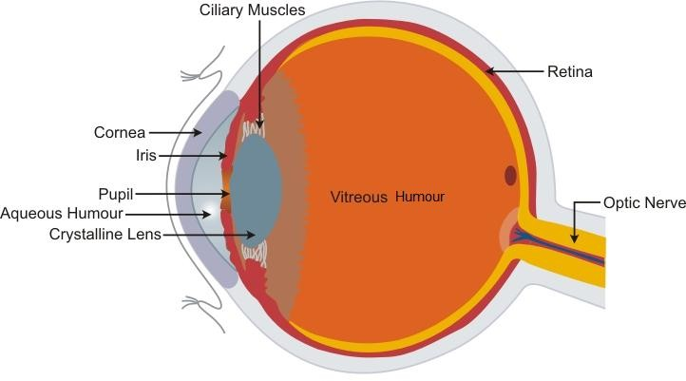

* The various parts of the human eye and their respective functions include

|  |  |
| --- | --- |
| **Part** | **Function** |
| Cornea | Protective layer of the eye  Refraction of light rays entering the eye |
| Eye lens | Adjust the focal length and form an inverted image of the object on the retina |
| Pupil | Regulates the amount of light entering the eye |
| Iris | Controls the size of the pupil |
| Retina | Acts as a screen for forming the image |
| Ciliary muscles | Adjust the thickness of the lens |
| Optic nerves | Send signals to the brain |

* The image of any object seen persists on the retina for

1 th

16

of a second, even after the removal of the

object. This continuance of sensation on the eye for some time is called **persistence of vision**.

* The numerous light-sensitive cells contained in the retina of the eye are of two types:
  + **Rod-shaped cells** which respond to the **brightness or intensity** of light.
  + **Cone-shaped cells** which respond to the **colour** of light.

.

## Power of Accommodation of the Human Eye

* Power of accommodation of the eye is the ability of the eye to observe distinctly the objects, situated at widely different distances from the eye, on account of change in the focal length of the eye lens by the action of the ciliary muscles holding the lens.
* The farthest point up to which the eye can see objects clearly is called the **far point (F)** of the eye. It is ideally **infinity** for a normal eye.
* The point of closest distance at which an object can be seen clearly by the eye is called the **near point (N)** of the eye. For a normal eye, the near point is 25 cm, which is called the **least distance of distinct vision (d)** of a normal eye.
* The distance between the far point (F) and near point (N) is called the **range of vision** of the eye.

## Defects of Vision

### Myopia or Short-Sightedness

A person with myopia can see nearby objects clearly but cannot see distant objects distinctly, as if the far point of the eye has shifted from infinity to some particular distance from the eye.

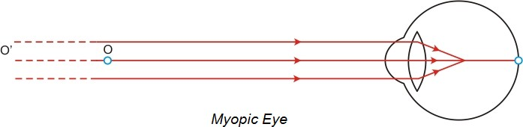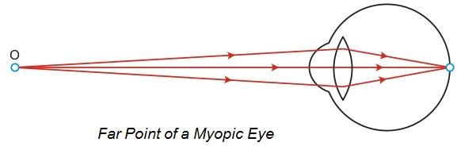

This defect may arise due to (i) excessive curvature of the eye lens or (ii) elongation of the eyeball.

To correct myopia, the person has to wear spectacles with a **concave lens** of focal length equal to the distance of far point of the myopic eye.

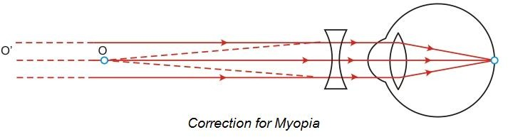

### Hypermetropia or Long-Sightedness

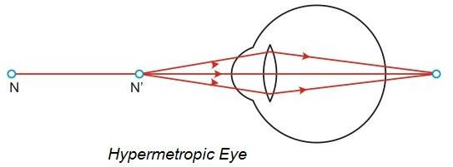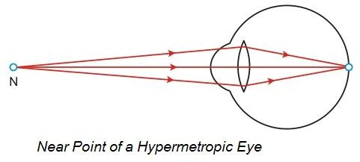A person with hypermetropia can see objects lying at large distances clearly but cannot see nearby objects clearly, as if the near point of the eye has shifted away from the eye.

This defect may arise because (i) focal length of the eye lens is too long or (ii) the eyeball has become too small.

To correct hypermetropia, the person has to wear spectacles with a **convex lens** of focal length f, given

by f 

x ' d x ' d

, where d is the least distance of distinct vision and x′ is the distance of near point N of the

hypermetropic eye.

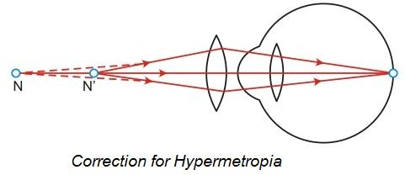

### Presbyopia

* Presbyopia is a human eye defect because of which an old person cannot read and write comfortably.
* It occurs in old age when the ciliary muscles holding the eye lens weaken and the eye lens loses some of its flexibility.
* To correct presbyopia, an old person has to wear spectacles with a **convex lens** of suitable focal length (as in hypermetropia).

Sometimes, a person may suffer from both myopia and hypermetropia. Such a person requires bi-focal lenses. The upper part of a bi-focal lens consists of concave lens facilitating distant vision, and the lower part consists of convex lens facilitating nearby vision.

## Dispersion of Light

* Dispersion of light is the phenomenon of splitting of a beam of white light into its seven constituent colours on passing through a glass prism.

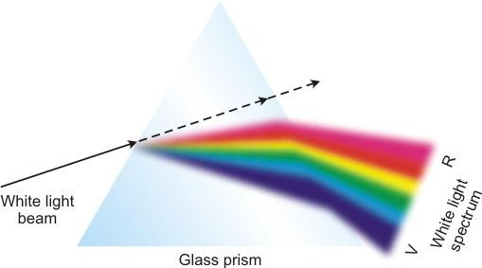

* The band of coloured components of a light beam is called its **spectrum**.
* The sequence of colours given by the prism is Violet, Indigo, Blue, Green, Yellow, Orange and Red.

**VIBGYOR** is the acronym for this sequence.

* The **cause of dispersion** is that different colours of white light with different wavelengths undergo different deviations on passing through a glass prism.
* If a second identical prism is placed in an inverted position with respect to the first prism, all the seven colours **recombine to form white light**.
* The **rainbow** is a beautiful example of dispersion of light in nature. Sunlight gets dispersed on passing through tiny droplets of water suspended in air during or after a shower.

## Atmospheric Refraction

* Atmospheric refraction is the phenomenon of bending of light on passing through the Earth’s atmosphere. This reason for this occurrence is that the upper layers of the Earth’s atmosphere are rarer compared to the lower layers.
* On account of atmospheric refraction of light,
  + The stars seem higher than they actually are.
  + The Sun appears to rise 2 minutes before and set 2 minutes later, increasing the apparent length of the day by 4 minutes.
  + The Sun appears oval at sunrise and sunset, but appears circular at noon.
  + The stars twinkle and planets do not.

## Scattering of Light

* The phenomenon in which a part of the light incident on a particle is redirected in different directions is called scattering of light.
* When the size of the scatterer (x) is very much less than the wavelength ( λ ) of light, Rayleigh scattering is valid. The intensity of scattered light (Is) varies inversely as the fourth power of wavelength ( λ ) of incident light.

**Is  λ4**

**1**

* The phenomenon of scattering of light by colloidal particles is called the **Tyndall effect**.
* On the basis of scattering, we can account for the:



Blue colour of clear sky

White colour of clouds

Reddish colour of Sun at sunrise and

Red colour of danger signals

sunset